**Laboratory Report   
DeVry University  
College of Engineering and Information Sciences**

**Course Number: DBM405A**

**Professor: Lively**

**Laboratory Number:** 7

**Laboratory Title:** Report Writing

**Submittal Date:** 6/17/2015

Note: There is no limit on how much information you will enter under the three topics below. It is important to be clear and complete with your comments. Like a scientist, you are documenting your progress in this week’s lab experiment.

**Objectives:** In your own words, what was this lab designed to accomplish? What was its purpose?

This lab’s purpose was to strengthen what we learned last week in first establishing a connection to our database from a programming language, and then also enhanced that skill and took it further by having us generate reports (display queries) that worked with information in our database. At the end of successfully creating the programming code needed to construct and perform these queries, we needed to write a command that would display/print the information to the screen for a user to read if need be. This directly relates to our course project for the week as well in using the power of a programming language to essentially create and work with a user-application that enables a regular user to access information from within the database.

**Results:** Discuss the steps you used to complete your lab. Were you successful? What did you learn? What were the results? Explain what you did to accomplish each step. You can include screen shots, code listings, etc. to clearly explain what you did.

Please see the following code/screenshots for each number/step of the lab to see how each step of the lab was successfully achieved:

* 1. Create a report to print the upcoming schedule.

In this step we create a query that lists the play date of each game and the name of the home team and away team which suffices as a method to report the upcoming schedule.

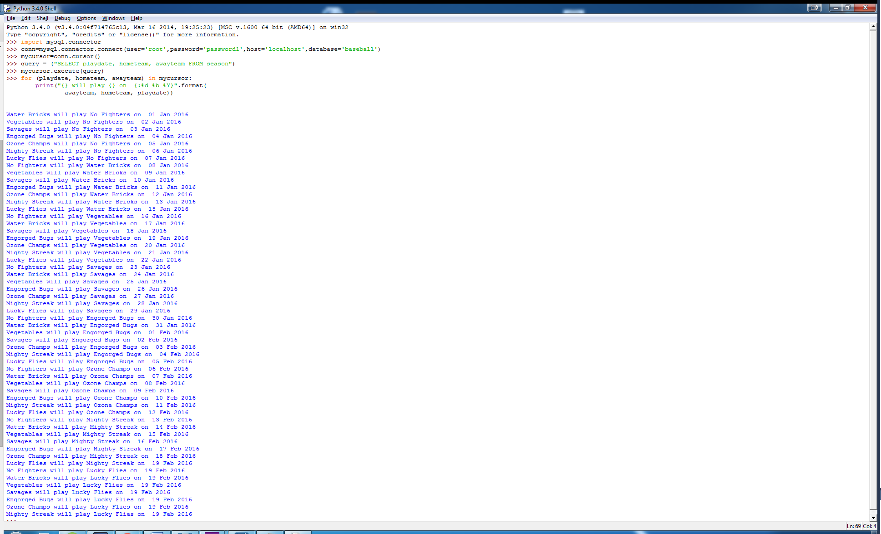

* 1. Create a report to show the team rosters.

In this step we create a query that joins two tables together in order to provide the results/report sufficient to make a team roster: team name (teams table), player name (players table), and player phone number (players table).

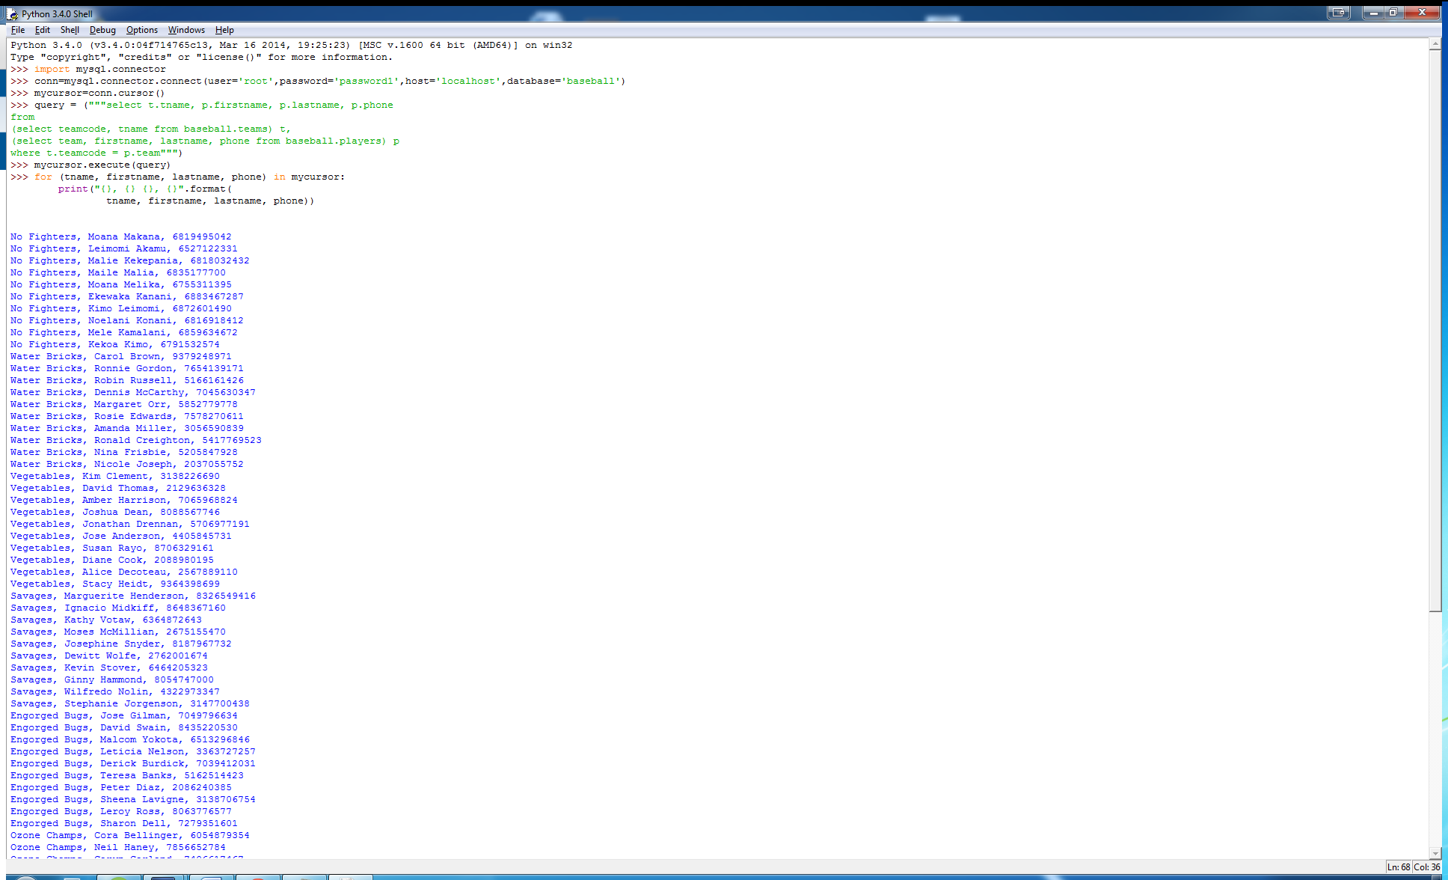

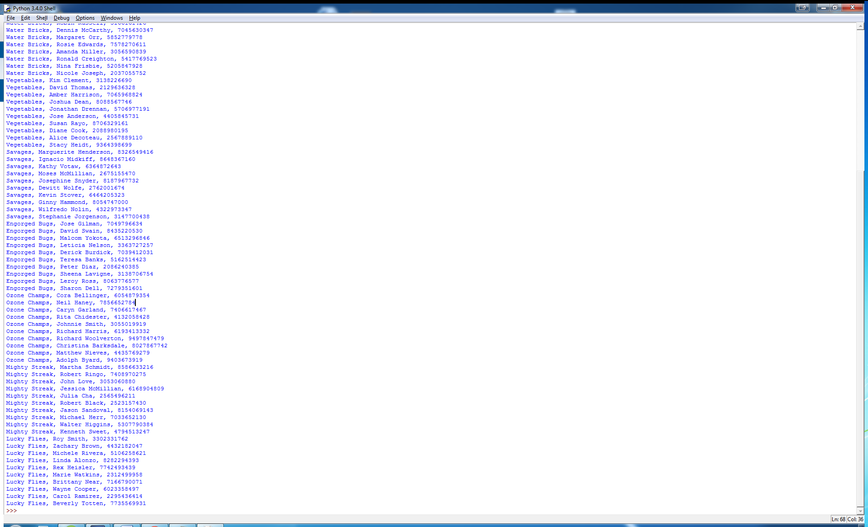

**Conclusions:** After completing this lab, in your own words, what conclusions can you draw from this experience?

This lab, as the professor in the video lecture stated, was meant to be fairly easy. Depending on the order you did your course work, you may have even done this almost exactly already in your course project for the week. To make things challenging I used a language I am not familiar with in Python (also used in last week’s lab to establish a connection). For me, the most difficult part was figuring out how to get a long query to work properly in Python. Turns out if strings are too long it gets broken up into multiple lines, and you need “” double quotes at the start and end to signify its altogether. Using the .format command also helped somewhat in presenting a tidy results/report set. Having done my course project in Visual Basic it was slightly different syntax-wise, such as when you press enter in Python it tries to execute the command immediately and if there are issues with it, it can make your text input very cluttered. Once it is working properly, however, it is very easy. Probably easier than Visual Basic, as you can see from the minimal amount of code needed to generate the report.

|  |  |  |  |  |  |
| --- | --- | --- | --- | --- | --- |
| **Student:** | Anthony Meunier |  | CIS |  | Anthony Meunier |
|  | Name |  | Program |  | Signature |